Professional Computing - CITS3200 Team 30

**Team Meeting #8**horizontal line

**Date:** 11/10/22  **/ Time:** 8.00pm **/ Location:** Teams

**Chair:** Edward

**Minutes:** Alexia

**Attendees:** Jordan Lee, Zack Zou, Edward Giles, Alexia Fassetta,Nicodemus Ong ​

**Apologies:**

**Minutes Duration: 60 mins**

# The meeting was declared open at 8.00 pm, quorum was present.

# The meeting was declared closed at 9.00 pm, quorum was present.

## **Confirmation of Previous Minutes**

**Motion:** “To accept the 06/10/22 minutes as true and correct”

**Moved:** Edward

**Moved Unanimously** / Moved by Majority

**AGENDA:**

| **Topic:** | **Actioned**: |
| --- | --- |
| 1.1 Update and further actions for specific tasks. | All |
| 1.2 Delegate New Goals/ Tasks | All |
| 1.3 Concerns, comments, further discussion | All |

## **1.1 Update and further actions for specific tasks.**

**Data Migration Tables:**

* For the excel data files that were created by Alexia and Nic, these will need to be converted from the String to the integer equivalent
  + Eg; Change the data from eg: “Casual, Full time, Part time” to “0,1,2”
* **Further Action:** 
  + **Nic -** Declare these choices in Model.py
  + **Alexia -** refactoring of the excel tables to align with those integer equivalent values as per Model.py

**Django Local Host Features:**

* **Update from: Jordan and Zack**
* Blue and Underlined words - act as a sort function
* Search bar
  + If there are special characters, we have checked to make sure the page doesn't crash, instead it will return nothing.
* Drop down for the Tables

**Changes to the tables on the front end:**

* **Update from: Zack**
* Remove personAddress (Address is now added to the table).
* Remove Country
* Add Student table (make accessible through the Django admin interface)
* Add Grants table

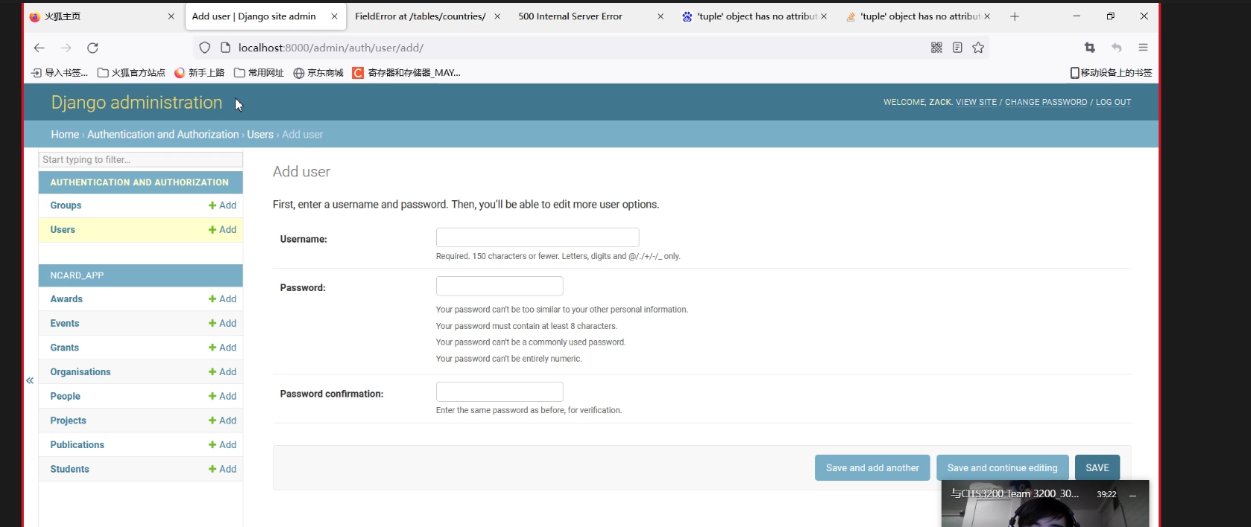

**Cross Button:**

* **Update from: Zack/ Jordan**
* Cross bottom to close the edit page should the admin not want to save.
* Avoids needing to use the back tab on google browser
  + **Further Action:** Zack to update this.

**Lazy Pagination:**

* **Update from: Zack**
  + Reduces the computational speed and improves user experience
  + Can we use different paginates for different tables?
  + Decision Agreed upon: use **non-lazy pagination** for all tables including publications.

**MultiTable Queries**

* **Update from: Edward**
  + Can select fields and have the fields you selected in the results
  + **Further Action:** work out the filtering.

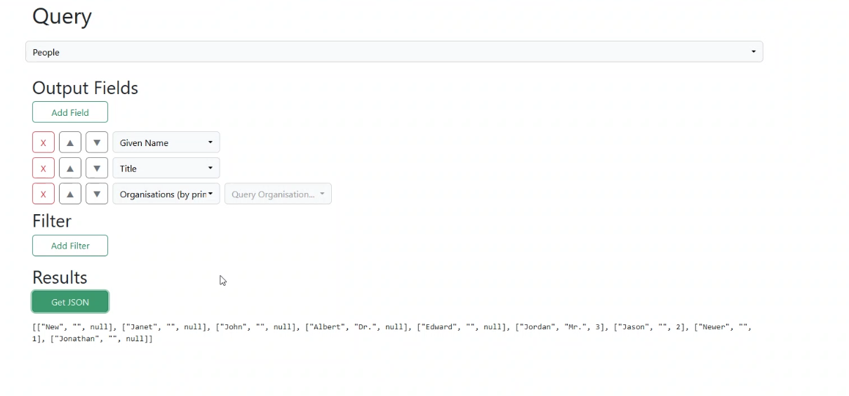

## **1.2 Delegate New Goals/ Tasks:**

**JORDAN:**

* Ensure tables in proper CSS format
* Finalize ‘Lock in’ pages
* Aim to finish the front end for Saturday.

**ZACK:**

* Change the related names for the foreign keys

**NIC:**

* **Edit Backend toFinalise model.py** 
  + Add PersonAddress to the People's table in the model.py
* **All Team;**
  + Changes for models.py wil now only be made on Nic’s Branch
  + All members to declare the changes to Nic who will then make it on his branch

**ALEXIA:**

**Installation Guide**

* Tanya’s local machine:
  + Download the repository from github to run on her device
* Considerations:
  + Enabled virtualisation
  + Enough Space
  + Consider Differences in Tanya’s system vs ours
* Software:
  + Docker, Django, Vs code
* Multiple people
  + Ensure connection/ access to the web server/ database with multiple users
  + Network administration
* Create super user - command typed directly into the user server
* How to create new user:
  + Docker (register an account)
  + Django Administration



**User guide**

* Local host vs local admin
* Same instructions applied to all the tables (they work the same way)
* More guidance required for multi-table queries

**Documentation**

* Jordan and Alexia to complete from Saturday onwards

**Presentation**

* User stories
* Difficulties encountered
* Purpose

## **1.3 Concerns, comments, further discussion:**

**Jichunyang Li:**

* Email regarding contribution and professionalism marks for CITS3200
* Upload all your work to GitHub
  + if you can't upload some work to GitHub, you should submit an explanation to me, this explanation needs to be reviewed by all your team members), if you can't provide suitable evidence, your hours will not be approved.
* Nic, Alexia and Zack to look into this - Support from the whole team.

**Upcoming meetings:** Mentor meeting on Friday 2pm

* Proposed Agenda (Meeting #3);
  + Demo our solution's system
  + Technical communication with regards to the user guide & installation
  + Acceptance testing.
  + Team processes